Enable Port Mirroring (SPAN) on a SCALANCE Switch
Example: SW-Ops 192.168.30.30 (SCALANCE XC208G)
Copy all traffic on ports P0.1 to P0.7 to port P0.8, so a capture device (Wireshark laptop or IDS sensor) on P0.8 can see it.

Before you start
- Pick a free port as the mirror port. It stops carrying normal traffic.
- You need the switch's admin login.

Steps
Step 1 Open https://192.168.30.30 in a browser and log in as admin.
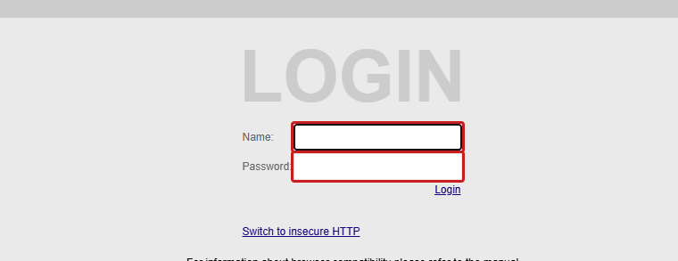
Step 2 In the menu, open Layer 2 > Mirroring.
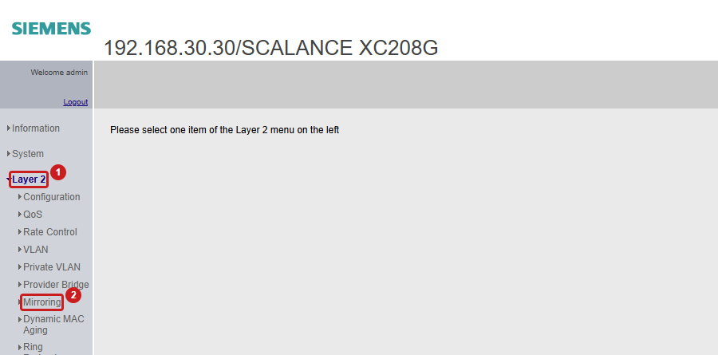
Step 3 On the General tab, click Create to add mirroring session 1.
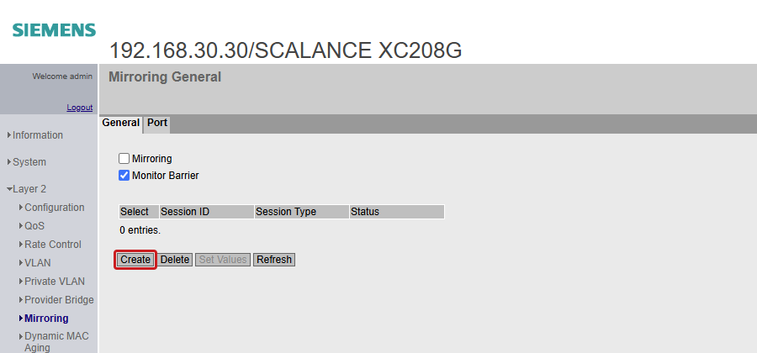
Step 4 In the session row, set Dest. Port to P0.8, then click Set Values.
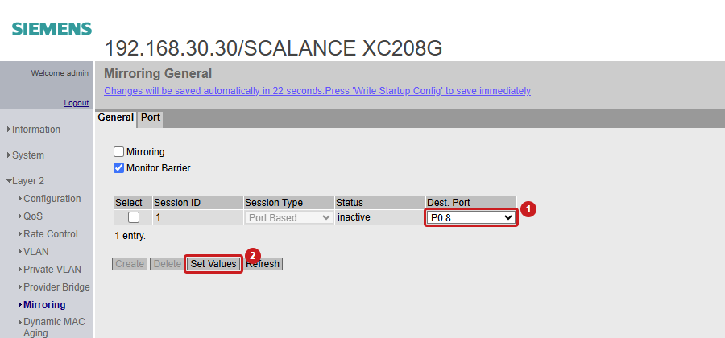
Step 5 Open the Port tab. Tick Ingress Mirroring and Egress Mirroring for P0.1 to P0.7 (leave P0.8 clear), then click Set Values.
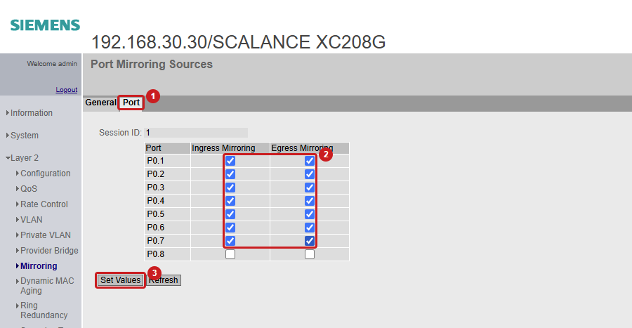
Step 6 Go back to the General tab, tick Mirroring, then click Set Values.
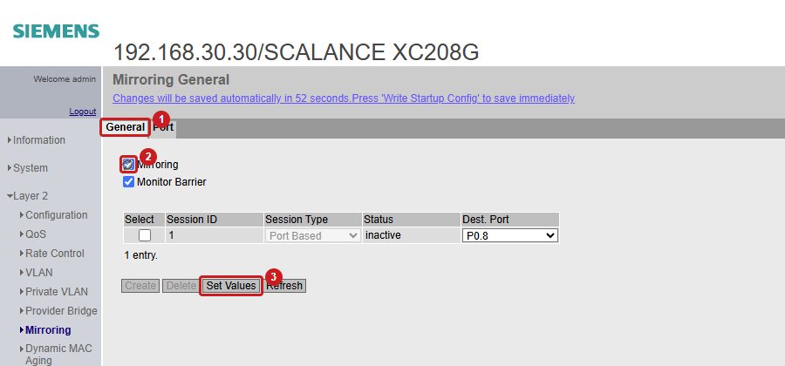
Step 7 Check that the session Status shows active. Port P0.8 now carries a copy of all traffic on P0.1 to P0.7.
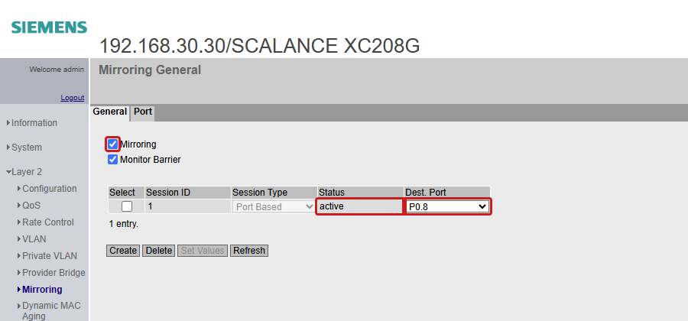
Step 8 Connect the capture device to P0.8. The switch saves the change by itself within about a minute.

Check from the CLI (optional)
Log in over SSH and run:
show monitor session 1

Session : 1
Source Ports
Both : Gi0/1,Gi0/2,Gi0/3,Gi0/4,Gi0/5,Gi0/6,Gi0/7
Destination Ports : Gi0/8
Status : Active

Undo
- Turn off: on the General tab, untick Mirroring and click Set Values.
- Remove: tick Select on the session row and click Delete.

